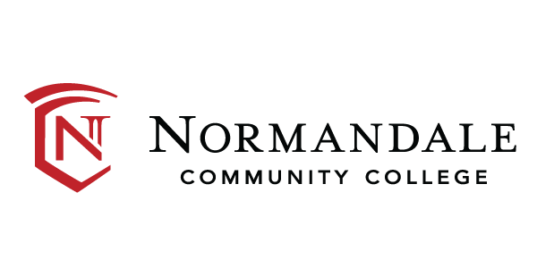

Democratic Engagement Action Plan
2026

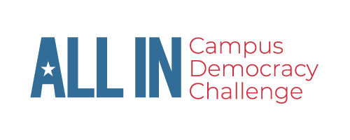

Table of Contents

Executive Summary
Leadership
Commitment
Landscape
NSLVE
Goals
Strategies
Reporting
Evaluation

Normandale Community College 2025 Nonpartisan Democratic Engagement Action Plan

Developed by: Eve Christensen

Executive Summary:

This nonpartisan democratic engagement action plan was developed by Normandale Community College in Bloomington, Minnesota for the 2026 election cycle. The purpose of this action plan is to increase nonpartisan democratic engagement and student voter registration, education, and turnout in the 2026 election. This plan further builds off a plan developed in fall 2024. We will continue to add contributing coalition members to discuss this plan with stakeholders as we develop our goals and outcomes. Although this document focuses on the 2025-2026 year, this will be a working document for future cycles of civic engagement education programming.

The goals for Normandale Community College for the 2026 election are:
- To encourage students to become and remain civically engaged not only during their time at Normandale, but as citizens of society.
- To increase voter registration and turnout among students.
- To create a welcoming and educational environment regarding civic and political engagement.
- To encourage staff and faculty to be civically engaged and instill this in students.
- To review the data from the National Study of Learning, Voting and Engagement (NSLVE) and continue creating assessment goals based on this information.
- To broaden contributing members and perspectives to this action plan as we continue this work.

Leadership:

Our coalition includes (but is not limited to) the following individuals, campus groups, and organizations:

Eve Christensen – Student Life Involvement Coordinator, Campus Voting Coordinator, & Student Senate Co-Advisor
Colleen Cahill- Director of Student Life
Jordan Shoulders- Student Services & Student Senate Co-Advisor
Shelly Oliver- Office for Students with Disabilities
Tim Lapanne- Director of New Student Programs
Chaz Berquist- Assistant Registrar, Normandale Records
Romeo Pech Moo - Student Senate President
Normandale Student Senate
Elizabeth Klages- Political Science Department
Politics & Law Club
Nancy Claycomb- League of Women Voters- Bloomington Board Member
Chris Peterson- Campus Store Manager
Marketing Department
LeadMN
ALL IN Campus Democracy Challenge

As we continue to develop this plan further, we hope to include more members and groups from the College and the community. We recognize that there are people, departments, and groups missing from our coalition and hope to open this opportunity to share perspectives for all who may be interested as we move forward. Incorporating the voices of the coalition and building opportunities to share responsibility and commitment to different elements of the plan will be instrumental in reaching our goals.

The role of the Campus Voting Coordinator is integrated into the position description of the Student Life Involvement Coordinator. Consistent meetings and communication will be essential to maintain momentum if the Campus Voting Coordinator transitions out of their role. This Action Plan, along with voting resources and information, will be documented, stored, and maintained in the Department of Student Life Teams channel.

Commitment:

Normandale Community College is committed to civic learning and engagement, as evidenced in the curricular, co-curricular, and extra-curricular programming offered throughout the academic year. By fostering collaboration amongst the clubs, organizations, academic programs, faculty, and staff members on campus, we work to make connections across departments and the institution.

Even though civic engagement is not explicitly stated within the mission, vision, and values, the espoused goals contribute to the experience of each student as an individual to inspire them to critically think and evaluate their opportunities and potential. Normandale is dedicated to the formation of well-rounded individuals where we cultivate a community of connectedness and to meet students where they are at. The community encourages curiosity, and learning more about civic engagement, politics, and elections falls under this category. This action plan aims to bridge our strategic plan with our goals of broader education and civic engagement.

Strategic Planning
- Mission
  - To cultivate a welcoming college community
  - To foster every student's talents
  - To build an equitable world
- Vision
  - Limitless human potential realized
- Values
  - Caring- We cultivate a college community where people feel a sense of belonging and connectedness. We recognize that people learn and work better when their needs are met and they feel safe. We have the courage to communicate with compassionate candor. We are a community of kindness and respect.
  - Curiosity- We nurture curious minds in our students and in our employees. We are genuinely curious about one another. Curiosity fuels our pursuit of learning and inspires us to find better ways of doing things. It drives us to ask good questions and to seek information to answer them. We are a community of curious people.
  - Commitment- We work hard to achieve our mission and goals. We dedicate ourselves to meeting all our students where they are and helping them pursue their aspirations. We are conscientious stewards of the college's resources. We are a community that expects a lot of ourselves and takes pride and joy in our work.

The Normandale Student Senate has taken a lead on civic engagement initiatives at Normandale. This past year, the Senate hosted Constitution Day and National Voter Registration Day events in collaboration with LeadMN, in which students were registered to vote and were provided information and literature regarding the voting process. Senate has also worked closely with The League of Women Voters Bloomington branch in hosting a tabling session for Voter Education Week, as well as partnering with Braver Angels for a Skills for Disagreeing workshop, and an event with various academic departments to host an event educating the community on the role of the Electoral College. On National Voter Registration Day, we hosted MN Secretary of State Steve Simon for a Corner Cafe chat to engage with students. Student Senate also invited the Bloomington City Clerk to table a week before the election to share information with students about the voting process, explain ranked-choice voting, and distribute voter information for Minneapolis-St. Paul metro-area elections.

The role of Campus Voting Coordinator helps to bring continuity and organization to the coordination of the voting process, including voter registration and educational opportunities. This role will also include working with various departments within the College to inform students and make information more visible and available. Registration forms will be accessible to all students, and Student Senate will be consulted on distribution methods and facilitating events to assist students in registering early and same day registration.

Normandale is committed to providing students with accurate, nonpartisan information. Students can view their ballot, find links to register to vote, and learn about the history and importance of civic engagement on Normandale’s voting page. Students can view voting information and resources on the Normandale website: https://www.normandale.edu/current-students/get-involved/voting.html

Normandale Community College does not have a current signatory to ALL IN’s Presidents’ Commitment to Full Student Voter Participation, due to a Presidential transition in the summer of 2025 to an interim President. We will work toward this designation in 2026.

Normandale Community College received the ALL IN Gold Campus seal for the 2020 election for their excellence in student voter engagement with a voting rate between 70-79%.

Normandale was additionally recognized as a 2024 Most Engaged Campus for College Student Voting by ALL IN.

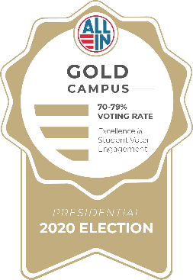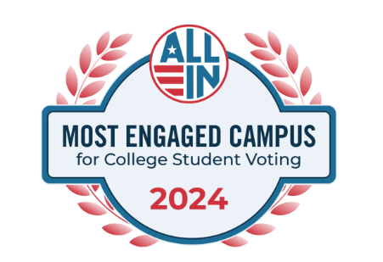

Landscape:

Normandale Community College is a public 2-year institution within the Minnesota State Colleges and Universities system. It is located in Bloomington, Minnesota. Normandale was founded in 1968 and is the largest community college and second largest undergraduate institution in the Minnesota State Colleges and Universities system. In FY24, Normandale served nearly 15,000 students in our for-credit courses and awarded more than 1,200 degrees and certificates in 60 programs of study.

Normandale Community College joined the ALL IN Campus Democracy Challenge in 2024.

Our campus demographic and voting data:

- In fall semester 2024, Normandale Community College had 11,169 enrolled students.
- 34% were full-time, while 66% were part-time
- 49% were returning students
- 75% were underrepresented
- 24% were First Generation
- 52% were Pell Grant eligible
- 51% were Students of Color
- The vast majority of students ~90% are in-state students from the 7-country metro area of Hennepin, Dakota, Scott, Carver, Ramsey, Anoka, and Washington counties.
- All students are considered commuter students, as Normandale Community College is not a residential institution.
- 36% of enrolled students were in high school as part of a concurrent enrollment, post-secondary enrollment, or special high school program.

Campus engagement has been increasing steadily following the outbreak of COVID-19 in 2020. Within Normandale there has been support across departments and divisions and from the community for involvement in general, and in terms of democratic engagement. We have connected with many organizations about voter registration support and have worked with the League of Women Voters-Bloomington, LeadMN, and local government entities to host events on campus to educate students about voter registration, important election dates, what election day looks like, etc. Faculty have encouraged their students to attend these events and have sometimes offered extra credit to their students for attendance. Many of our students participate in a hybrid or fully virtual classroom environment. Involving these students and offering robust and meaningful programs for this demographic has been a significant challenge.

Normandale Community College has authorized the National Study of Learning, Voting, and Engagement (NSLVE) through 2033 and will receive campus voting data in the future from Tufts University.

Below are the results from the 2022 NSLVE campus report. Further detailed data can be found here: NSLVE Campus Report 2022

Figure 1: Overall Student Voting Rate
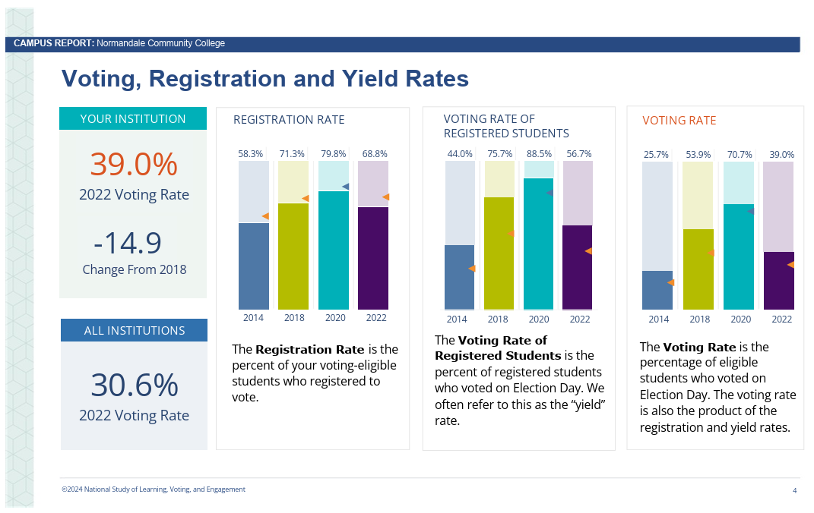
Figure 2: Student Voting and Registration Rates
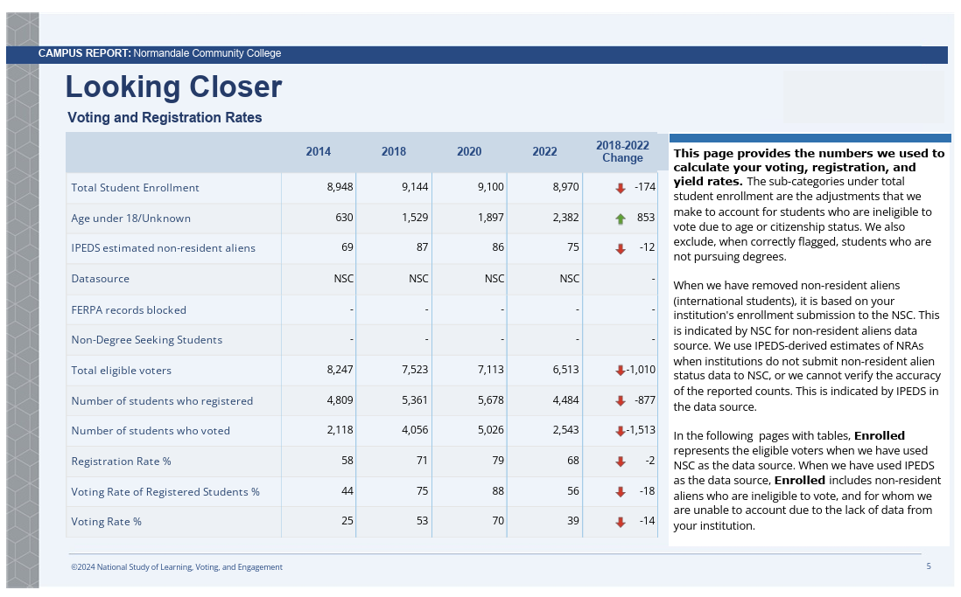
Figure 3: Comparison of Student Voting by Race & Ethnicity
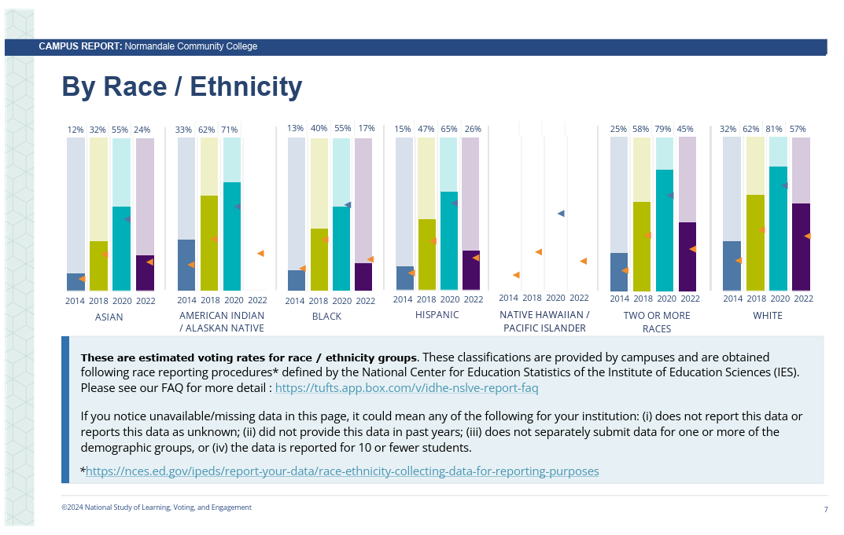
Figure 4: Student Voting by Method
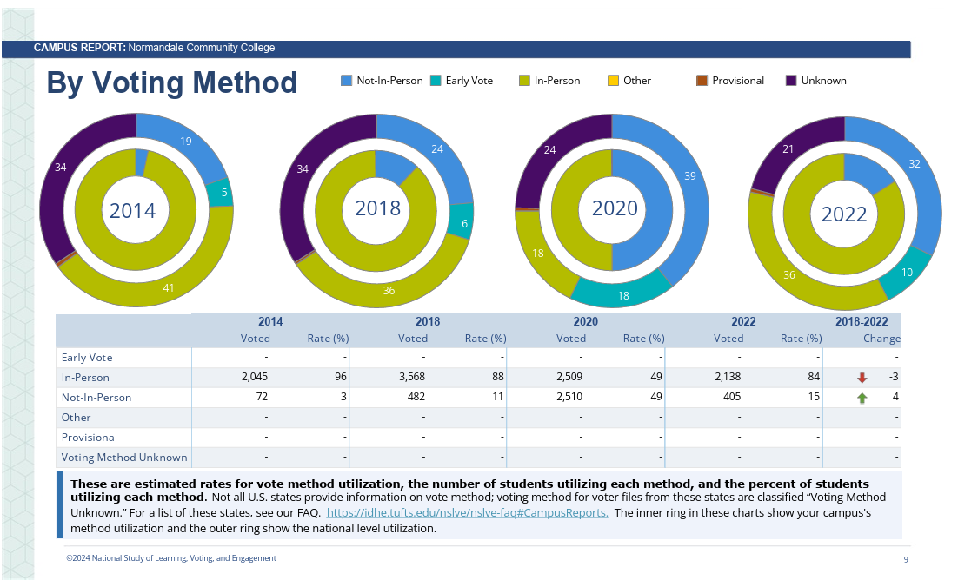
Normandale Community College participates in the following initiatives to support the development and implementation of our nonpartisan democratic engagement efforts on campus:

- ALL IN Campus Democracy Challenge
- Ask Every Student Commitment Campus
- Constitution Day
- Mock Election initiative
- National Voter Registration Day Community Partner
- League of Women Voters- Bloomington Tabling at Campus Involvement and Resource Fairs
- Student Senate Voter Registration Tabling events
- Students Learn Students Vote (SLSV)
- TurboVote access for students to find their voter registration information

The Minnesota State Legislature has also passed legislation in 2023 to ensure additional accountability measures be in place at Minnesota colleges and universities. The requirements include:
- Designation of a campus voting coordinator
- Provide registration forms to each student each semester
- Consultation with campus student government
- Accessible webpage on the college website with voter and election information
- Submission of annual campus voter engagement report/plan
- Preparation of the list of currently enrolled students
- Written agreement to the county auditor to provide student housing lists for each election year

Important Minnesota Upcoming 2026 Election Dates & Deadlines
- Precinct Caucuses February 26th (unless parties notify Secretary of State of a different date)
- Vote by mail or in person June 26th through August 11th for the Primary
- Primary Election Day- August 11th
- Vote by mail or in person September 18th through November 2nd for Election Day
- Register in advance by October 13th to save time on Election Day
- Register same-day on Election Day on November 3rd
- Election day- November 3rd

Goals:

Normandale Community College’s nonpartisan democratic engagement goals are:

Short term goals (2026): Our focus this year will build on our coalition and create more campus-wide voter engagement opportunities. Regular touchpoints with coalition members and hosting events in collaboration with campus partners, along with our ongoing partnership with Student Senate will allow us to accomplish this. As a new Campus Voting Coordinator adjusts to the role, our goal is to continue strengthening community partnerships such as those with the League of Women Voters, Bloomington City Clerk, Braver Angels, and other voter engagement resources nearby. We also hope to grow more partnerships with faculty members to integrate our initiatives into the classroom.

Additionally, we look forward to partnering with Normandale’s new Student Communications Specialist, who will be a crucial part of the distribution of voter registration materials in spaces such as D2L (our online learning management system) and marketing our civic engagement programming, as well as helping us to assess our initiatives.

Long term goals (2-4 years in the future): More broadly, we hope to bring more visibility to our programming and goals, and to create more buy-ins from the campus community. We want to ensure that our goals and successes are known, and that the role of the Campus Voting Coordinator is understood. The Student Communications Specialist will also be a critical part of this goal.

Sustainability and creativity in our events is a large part of our long-term goals as well, ensuring that our events are fun and that folks look forward to how we engage with our student body civically. Smooth transitions between Campus Voting Coordinator roles are integral to the success of this goal as well; going forward, we hope to remain organized and motivated to pass the torch as needed.

Voter Turnout: Increase student voter turnout rate from 39% in 2022 to 54% in 2026, (reflective of pre-pandemic levels in 2018). With the commitment of our campus community and the dedication of the Student Senate, we believe this goal is achievable for a midterm election year.

Voter Registration: Increase voter registration rate from 68.8% in 2022 to 75% in 2026, to exceed pre-pandemic rates. This will require a significant focused effort, as a large portion of our students are PSEO or dual-enrollment students under 18. However, we believe we can reach folks through a variety of means (in-person, evenings, and virtually) to achieve this goal.

Participation gaps: Address participation gaps in NSLVE data and aim to work with students in identity groups that had lower turnout rates, focusing on early and absentee voting options that have seen an increase in vote method utilization, and which may be more accessible to our student population.

Programmatic Goals:
- Increase participation in our Campus Voting Coalition
- Integrate voter registration into annual campus traditions and events
- Utilize our current student ambassadors to share voting resources and information
- Strengthen and develop relationships with local election officials
- Develop online and asynchronous voter engagement programs and opportunities
- Have our current interim president, as well as the newly selected president sign the ALL IN Higher Education Presidents’ Commitment to Full Student Voter Participation in the coming year.

Metrics and evaluation:
- Continue to track attendance at events and registrations collected
- Develop surveys and strategies to evaluate effectiveness of our programming

Strategies:

Normandale Community College will implement these strategies to increase nonpartisan democratic engagement and student voter participation.

- Utilization of Civic Holidays such as Constitution Day, National Voter Registration Day, National Voter Education Week, Vote Early Day, and Election Hero Day
- Voter registration information and tabling during Welcome Week, Orientation sessions, Involvement Fair, Wellness & Resource Fair in the early fall
- Educational events such as speakers and workshops in collaboration with the League of Women Voters- Bloomington and LeadMN on topics such as the history of social justice and civil rights and voting, voter suppression, civil dialogue, the electoral college, the importance of local elections, creating space before and after the elections, voting resources as well as candidate forums, panels, tabling etc.
- Offer information for faculty to share with students on Desire to Learn (D2L), our online Learning Management System.
- Collaborate closely with student groups, particularly identity-based groups such as Asian Cultural Club (ACC), Latinos United at Normandale in Action (LUNA), Black Student Union (BSU), Muslim Student Association (MSA), etc.
- Work side by side with the Normandale Student Senate on tabling, Mock Election, and civic holiday events. Additionally, review the NSLVE data and action plan with the Senate and any other interested constituents at the college.
- Integration of more creative and varied event modalities that allow our students to take part in civic engagement, such as evening and online programming.

The following table highlights initiatives that are required by the State of Minnesota, as well as additional general tasks that will help us achieve our goals.
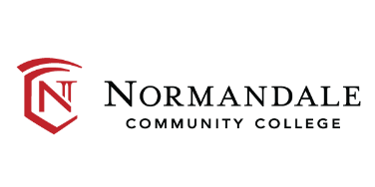
Voter Engagement Plan
FY26
# | Initiative / Task | Deadline / Timeline | Person Responsible, Partners | Results/Recommendations for Future
Required Tasks per Policy 2.3.1.1 – Student Voter Registration
 | Transmit a message of referral to a centralized voter registration website or platform that provides voter registration forms. Each campus shall identify one person to be the “Campus Vote Coordinator” to ensure compliance with this procedure. The Coordinator’s contact information must be posted on the institution’s website. | Transitioned to new Coordinator in Oct. 2025 | Eve Christensen; MarComm team | Website: https://www.normandale.edu/current-students/get-involved/voting.html
 | Consult with their campus student association to determine the most effective means of distributing voter registration forms, supporting election day registration of students, and how to promote ‘get out the vote’ activities. | Throughout summer and fall 2026 meetings with Student Senate | Eve Christensen;  Student Senate; Senate Director of Legislation
 | Provide students attending on-campus orientation with a physical voter registration form or access to the online form. | In place- In Zone Org offices; Senate space in English, Spanish, Hmong, Somali and other languages available upon request | Eve Christensen;  Tim Lapanne (New Student Enrollment Coord.)
 | Provide students attending an online orientation with a link to the Minnesota Secretary of State’s website or another centralized voter registration website or platform that provides voter registration forms. | In place (Check in with Tim) | Eve Christensen;  Tim Lapanne
 | Communicate to students who reside in Minnesota, North Dakota, South Dakota, Iowa or Wisconsin as early as possible in the fall semester the instructions for how students may register to vote, making available information regarding State registration deadlines, residency requirements, and absentee voting, as applicable. | Provided via TurboVote access on Normandale website. | Eve Christensen;  Marketing & Communication Team- Steve Geller, Dir. Of Media & Public Relations
 | Communicate a reminder to students after the voter registration deadline has passed on how they can register to vote on Election Day. | This info will be provided fall semester through October 13th and then same day registration info will be provided. | Eve Christensen; MarComm Team; Student Senate | - Communicated via the Roar; Student Senate tabling; TVs
 | Ensure that all physical Minnesota voter registration forms received from students at the campus are submitted in timely manner to the Minnesota Secretary of State or county elections office. | October 13 deadline to mail in forms (encourage students to register online) | Eve Christensen;  Student Senate; LeadMN- for forms collected when they are present | - In past we did not collect the forms, we just made them available  - LeadMN may collect the forms that are filled out on voter reg. day
Additional Tasks
 | Request Student assistance with voter engagement efforts/Voter engagement workgroup. | Senate will work on this via tabling and promoting on social media through Nov 3rd | Eve Christensen;  Student Senate
 | Celebrate and promote Civic Holidays: Constitution Day, National Voter Registration Day, National Voter Registration Week, Vote Early Day, and Election Hero Day | Ongoing each year – all programming done in collaboration with Student Senate | Eve Christensen;  Student Senate
 | Promote Voter Registration on campus via posters on campus | Posters up on campus via Senate and Student Life | Eve Christensen;  Student Senate | Put these up with help of Senate
 | Create TV slide promoting Voter Registration | Student Life will send to Pavel | Eve Christensen;  Pavel Ignatenkov | Senate PR chairs to create imagery
 | Work with students interested in voter engagement efforts/Campus Voting Coalition to implement ideas/respond to feedback. | Ongoing | Eve Christensen;  Student Senate | Partner with League of Women Voters- Nancy Claycomb

Evaluation:

We seek to evaluate the effectiveness of our efforts to increase voter turnout and civic engagement on campus. Assessment and evaluation may live in the Department of Student Life with assistance from the Institutional Research Department for further analysis of our results and data collected.

NSLVE Data: Normandale Community College has authorized the National Study of Learning, Voting, and Engagement (NSLVE), and we will use our campus voting data to help with the evaluation of our action plan and nonpartisan democratic engagement efforts. As 2024 was the first year of our action plan, we will look to the results of the next NSLVE report in order to assess our goals and outcomes in terms of voter registration, turnout, and engagement.

Metrics beyond NSLVE data:
We will look to collect data via methods such as:
- Attendance at events,
- Number of pledges to vote,
- Voter registrations collected at events,
- Surveys to collect further information about the audience receiving our messaging

Data Collection: Our institutional research department will be an important team member in evaluating and assessing our metrics. The Department of Student Life and Student Senate will be collecting most if not all of the data, as the organizers and staff of the events hosted on campus.

Ideas for data collection include student ID swipes, surveying student attendees at events and voter registration forms. We will store this data in our Normandale Campus Voting Coalition Teams channel. This data will be collected and organized in order to inform and contribute to future action plans and future coalitions.

Reporting:

This action plan will be shared internally and externally. The campus action plan and NSLVE reposts will be shared on and be made available to administration and all students on the Voting Information and Resources page on the Normandale Community College website: https://www.normandale.edu/current-students/get-involved/voting.html

Our campus action plan will be posted on our campus page on ALL IN’s website https://allinchallenge.org/campuses/normandale-community-college/.

We will partner with our Student Communications Specialist and others in the Marketing Department to highlight updates, stories, and visibility of our initiatives, goals, and successes through the Student Roar Newsletter, human interest stories in the campus-wide Uplift newsletter, and on our website.

Normandale Community College has given ALL IN permission to publish our past NSLVE reports, which can also be found on our campus page above.

