**Chemistry Lab Pick-Up**

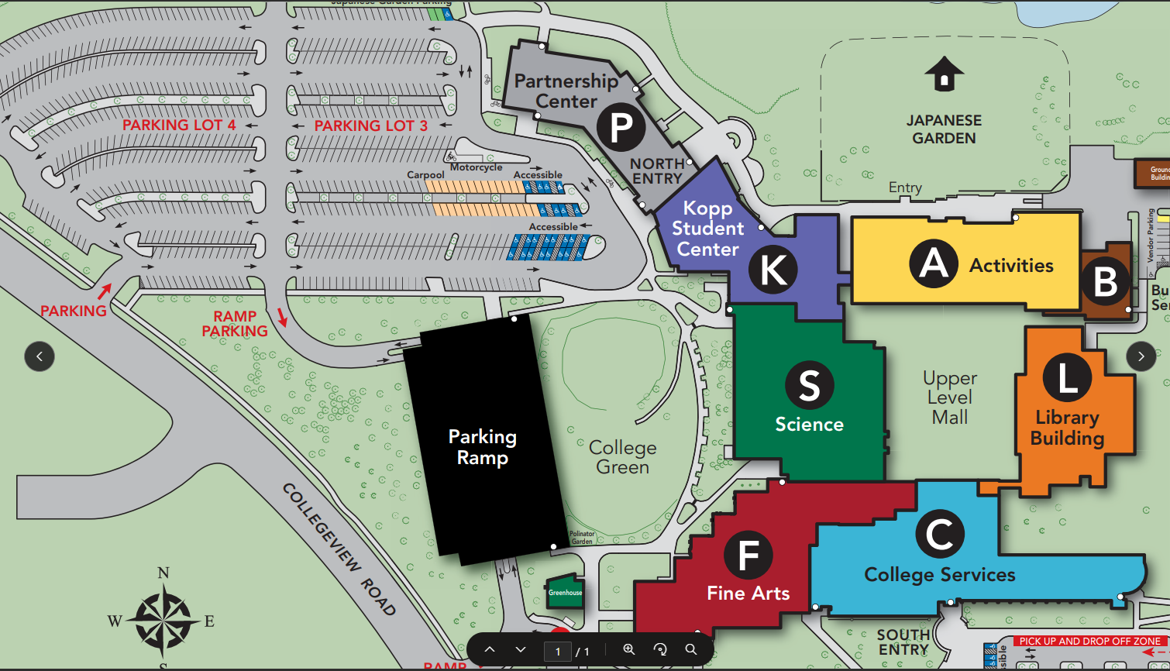

1. Park on the north side of campus, where parking lots 3 and 4 are located (See large red star).
2. From there, walk towards door 18 (see small red star), which is located in the Science Building, or to the right of the main entrance of Partnerships. Enter the doors and either:
3. Take the stairwell to the 2nd floor
4. Take the elevator to the 2nd floor
5. Go to the Chemistry Lab pick-up area – S2373